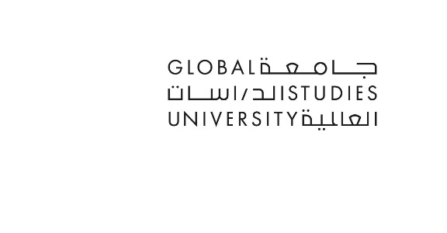
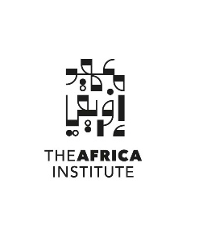

For Immediate Release
Open Society Grant: The Africa Institute Receives Major Multi-Year Funding for African Cultural Heritage Fellowship
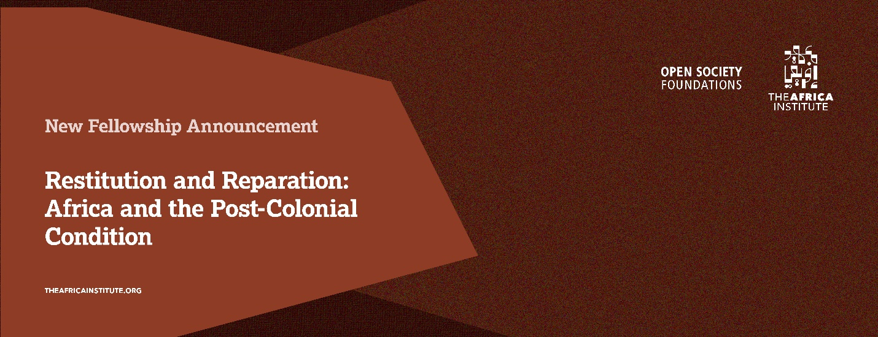
Sharjah, UAE – [09 May 2024] - The Africa Institute, Global Studies University (GSU), in Sharjah, UAE, has received a substantial multi-year grant of $180,000 from the Open Society Foundations. This generous support will fund a new fellowship program until September 2026 to tackle the complex and ongoing debate surrounding African cultural heritage and repatriation.
"We are incredibly grateful for the generous support of the Open Society Foundations," said Hoor Al Qasimi, President of The Africa Institute (GSU). "This grant will enable us to launch a vital fellowship program that brings together scholars and practitioners to explore complex issues surrounding cultural restitution and reparation, specifically related to African art and artifacts."
The debate over restitution and repatriation of artifacts looted during colonial occupation has been raging since the 1970s with limited progress. As Professor Salah M. Hassan, Director of The Africa Institute has asserted, “The Fellowship will help enhance and refocus the debate on restitution and repatriation which seems to have stalled despite the limited progress in repatriation’s gestures by several Western-based museums. It will help move the discourse beyond appeals by political groups into a much critically grounded scholarship and public engagement.” A wealth of art and artifacts pillaged by European and North American colonial regimes are currently in the possession of Western museums and other collectors, who have long asserted their roles as custodians of these items. The refusal to return such artifacts to their Global South origins is persistently argued using claims such as lack of specific provenance, insufficient spaces for display, and storage spaces lacking proper conditions (climate control, security systems, etc.) to conserve such pieces in the countries of origin.
There is an abundance of artifacts, human remains, and cultural heritage acquired by colonial powers that are still being housed by Western institutions today. Recent years have experienced a surge in the concentration of international debates and advocacy around the subject of the repatriation of such artifacts. Although several state and private institutions in the United States and Europe have pledged their support of repatriation, it is unclear how this support fits into the larger conversation around cultural restitution and reparation. As a result of this lack of clarity, nationalist policymakers have established new strategies, including campaigns, to address policies and obstacles around the repatriation and restitution of cultural heritage. The recent gains resulting from ongoing efforts for reparation for colonial injustices and racial reparation should be studied to ensure continued progress.
The annual fellowship program themed, "Restitution and Reparation: Africa and the Post-Colonial Condition," will convene scholars or practitioners interested in restitution and repatriation issues related to African art and artifacts. By fostering dialogue and research, the program aims to shed light on this critical issue and contribute to meaningful progress in returning looted artifacts to their rightful homes in Africa.
This fellowship program aligns with The Africa Institute's broader mission to foster critical thinking and dialogue around African and African diaspora studies. By bringing diverse voices and perspectives together, the program promises to advance crucial conversations about cultural heritage, historical accountability, and the path toward a more just future.
Beyond the Open Society Grant fellowship, The Africa Institute's Research Fellowships Program offers additional opportunities for established and emerging scholars to delve into research on Africa and its diaspora. The program boasts senior fellowships named after literary icon Toni Morrison and renowned scholar Ali A. Mazrui, honoring their significant contributions to understanding Africa's global connections.
Furthermore, the program features postdoctoral fellowships dedicated to the memory of scholar, curator, and art critic Okwui Enwezor and world-renowned Moroccan scholar Fatema Mernissi. These fellowships support emerging researchers exploring diverse aspects of African and African diaspora cultures, thereby enhancing the depth and diversity of intellectual inquiry.
The first cohort will join this fall, in September 2024. The open call for our fellowships will begin in June 2024. Visit our website, theafricainstitute.org, to learn more.
About The Africa Institute, Global Studies University (GSU)
The Africa Institute is a globally oriented institution of research, documentation, study and teaching of Africa and its diaspora, in the humanities and social sciences. It is conceived as a research-based think-tank, and a postgraduate studies institution (offering both master’s and Ph.D. programs, and diplomas in African Languages and Translation), which aims to train a new generation of critical thinkers in African and African diaspora studies. The Africa Institute is proposed to be a model center of excellence in research, teaching, and documentation that is hoped to match in quality and breadth of coverage, existing peer of African and African Diaspora Studies in Africa, Europe, and North America. The Africa Institute is now integrated into the newly established Global Studies University (GSU) to form one of its networks of semi-independent institutes and colleges, each concentrating on different regions of the world. These globally oriented institutions aim to focus on postgraduate studies, research, and documentation of histories, cultures, and peoples who constitute different regions of the world. The next entity to be officially established in 2024 is The Asia Institute, College of Asian Studies. Preparations are also underway to launch additional colleges and institutes that will focus on the regions of Oceania, Europe, and the Americas in the next few years. The Africa Institute is led by Director Professor Salah M. Hassan and President, Hoor Al Qasimi. Visit theafricainstitute.org for more information.
About Open Society Foundations
The Open Society Foundations, founded by George Soros, are the world’s largest private funder of independent groups working for justice, democratic governance, and human rights. Visit opensocietyfoundations.org for more.

For press information please contact
Megna Kalvani, Communications & Outreach Manager:
T: 971 6 5112415 | M +971 50 241 0577 | megna.kalvani@theafricainstitute.org

